WINDOWS DESKTOP EDITION

Delphi Web Studio Pro User Guide
Editor controls and practical examples
Last changed November 8, 2026 • Win32 and Win64
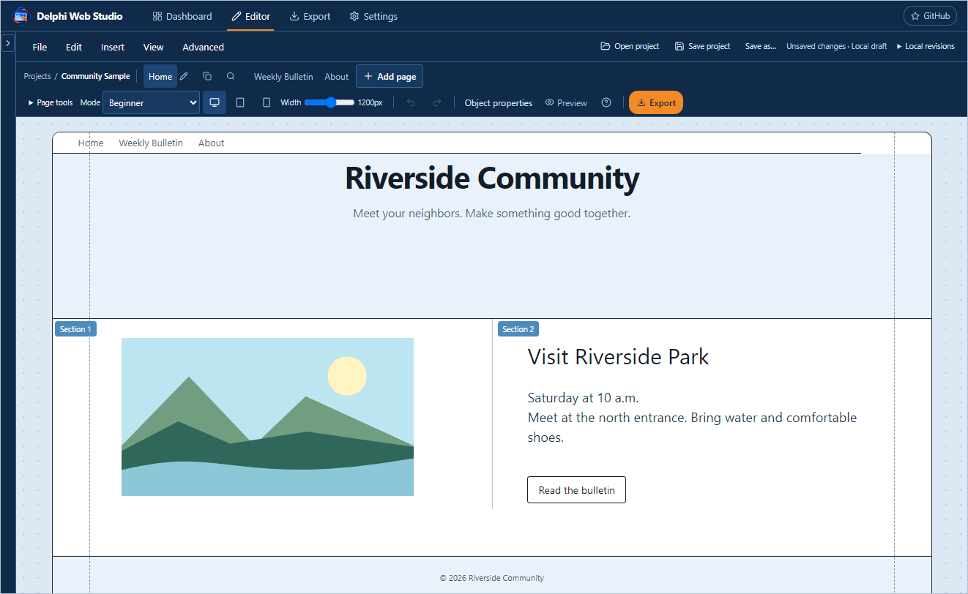
Riverside Community is the fictional example used throughout this guide.
Start a site, add and arrange elements, manage media, and check what visitors will see. Use the contents to find a control or follow a worked example. The guide covers the experimental Windows build through source revision 02bdd3b.
Contents
Start here 3
Dashboard and project cards 4
Save open and exit 5
Backups and local revisions 6
Find your way around the editor 7
File edit insert and view menus 8
Create and manage pages 9
Page addresses and search details 10
Plan pages and check the site 11
Preview and responsive layout 12
Undo history and keyboard controls 13
Components and layers 14
Select move and resize 15
Layer order and overlap 16
Reading the layers and object tools 17
Floating settings windows 18
Block and item property fields 19
Build and resize sections 20
Add and edit text 21
Text boxes and content blocks 22
Panels buttons and attached objects 23
Space strips and decorative lines 24
Link to a page or an anchor 25
Find and import media 26
Manage a large media collection 27
Image blocks and image objects 28
Galleries and layered collages 29
Video audio and documents 30
Create and update a weekly bulletin 31
Read a PDF in the viewer 32
Navbar controls and page links 33
Footer and linked resources 34
Hero content and announcement blocks 35
Cards lists and social proof 36
Contact forms and newsletter controls 37
Set the site design 38
Site settings and search 39
Articles author credits and tags 40
Import HTML and WordPress content 41
Project JSON and custom code 42
Optional AI and saved keys 43
Export and review website files 44
Hosting and deployment controls 45
Troubleshooting and final checks 46

Start here
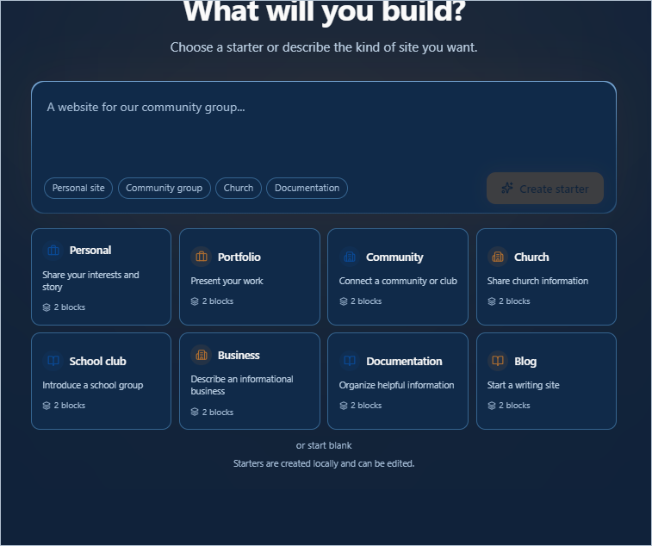
The Dashboard offers starter cards and a blank project. Your project list appears below after you create or open a project.
Open Delphi Web Studio Pro from bin\Win64 or bin\Win32. Keep the executable, its editor folder and its WebView2 loader together. The main window opens to the Dashboard when there is no active editing session.

Your first practice site
1. Select Community to create a local starter. Select Editor if the canvas is not already open. Use Home as the first page.
2. Use Save to create Riverside Community.webstudio.zip after you add media. Keep this file as your editable master.
3. Add an Events page, link to it from the Navbar, then use Preview to try the link. Export a separate Website ZIP when you need files for hosting.
The examples in this guide use a fictional Riverside Community site. You can follow the same steps with a Church starter or an existing project.

Dashboard and project cards
Use the Dashboard to start a site, return to a local draft, or open a saved project from disk. The number beside Your projects counts drafts in this app profile.
Control | What it does
Open project | Open an editable project ZIP or JSON. In Windows, select the file and confirm Open. A website export ZIP has a different purpose.
All local revisions | Show snapshots across projects, including revisions belonging to a removed dashboard draft.
Describe your site | Enter a short brief such as “A website for our neighborhood garden.” The quick prompts fill in starter ideas for you.
Personal site, Community group, Church, Documentation | Put an example brief in the description box. You can replace or extend it.
Create starter | Create a local starter based on your brief. You can edit every starter block afterward.
Starter cards | Choose Personal, Portfolio, Community, Church, School club, Business, Documentation or Blog. The small block count describes the starting layout.
or start blank | Start with an empty Home page. Add a block before placing objects inside a section.
All, Published, Drafts | Filter project cards by saved app status. Clear filters returns to All and clears Search.
Search | Find a local project by name. This is a dashboard filter, separate from visitor site search.
Project card | Open the project in Editor. Hover or focus the card to expose its actions.
Rename, Duplicate, Delete | Change the local project name, make a separate local copy, or confirm removal of the draft. Keep your saved project file before deleting a draft.

Save open and exit
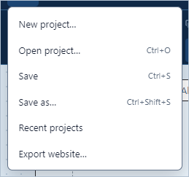
The Editor File menu mirrors common project commands. The desktop File menu also provides backup, restore and Exit.
Control | What it does
Open project / Ctrl+O | Open a saved project ZIP or JSON. If replacing a session with changes, read the save or discard prompt before continuing.
Save / Ctrl+S | Update the currently opened or saved project file. On first save, choose a name and location. In Windows, check the status shows Saved and the intended filename.
Save as… / Ctrl+Shift+S | Choose a different path or filename. Use it to make a separate working copy before major edits. Confirm an overwrite only for the intended file.
Status beside file controls | Working means the operation is in progress. Unsaved changes means another save is needed. Save failed means the file write was not confirmed. A browser download request requires checking the destination.
Desktop File → Exit or window X | Close the editor. When prompted for unsaved work, Yes saves before closing if the save succeeds, No discards the unsaved session changes, and Cancel returns to the editor.
Editor File → Recent projects | Return to the Dashboard. Open a saved project with Open project or resume a listed local draft.

Example. Open Riverside Community.webstudio.zip, edit Home, press Ctrl+S and wait for Saved. Open the same ZIP later to verify the edit. Use Save as to create Riverside Community before redesign.zip when you want both versions.

Backups and local revisions
Control | What it does
File → Back up project… | Create a separate recovery package using the desktop file dialog. Choose a location you control.
File → Restore project backup… | Select a backup and review the project replacement prompt. Save any work you intend to keep before replacing the open project.
Local revisions / All local revisions | Expand the revision list in Editor or Dashboard. A local revision is stored in this app profile and is separate from undo history.
Create local revision | Capture the current project and its media. Use a revision to record a checkpoint such as the point before rearranging Home.
Open as a separate project | Open a revision as a separate local project. Save that project to disk if you want to keep it outside this Windows profile.
Save revision as file | Write a portable copy of the selected revision to a destination you choose.
Remove… | Delete the selected local revision after confirmation. Removing a local revision is permanent.
Recover staged file… | Use this when the desktop startup screen offers a staged recovery file. Review the destination before attempting recovery.

Choose the right copy
Keep the project ZIP for editing and transfer. Keep a website ZIP for the published files. Use a named local revision for a short-term checkpoint. Save current work before closing Windows or moving to another machine.
Completed saves no longer retain a new automatic recovery folder for every save. If you find older recovery folders, check their contents and your current saved ZIP before removing them.

Find your way around the editor
The page tabs, viewing controls and canvas are visible together. The light page margins use the site background.
Control | What it does
Dashboard / Editor | Return to the project list or work on the active project.
Export / Settings / GitHub | Open website output controls, project and app settings, or the software repository in a browser.
File / Edit / Insert / View / Advanced | Open command menus in the editor. Click outside or press Escape to dismiss a menu.
Projects and project name | Identify the active site. Use the breadcrumb to return to the project list.
Left chevron | Expand or collapse the panel that holds Layers, Components, Media and Articles. It starts collapsed in the editor.
Object properties | Open the floating settings window for the current selection. With no selected component, choose one or use Site design.
Preview / question mark / Export | Switch to visitor view, see shortcuts, or choose an export action.

The blue patterned area is editor workspace. The dashed vertical lines mark the desktop safe content area in edit mode. Check the actual page without guides in Preview.

File edit insert and view menus
Control | What it does
File → New project… / Recent projects | Return to the Dashboard to pick a starter, start blank or select a draft.
File → Open project… / Save / Save as… | Open a file, update the current file, or create a separate saved copy.
File → Export website… | Open the Export screen for site files and review.
Edit → Undo / Redo | Step backward or forward through the current editing history. Use Ctrl+Z or Ctrl+Y outside a text field.
Edit → Cut / Copy / Paste | Use the text selection and keyboard equivalents if the browser restricts menu clipboard access. For a whole object, use its context menu where the command is offered.
Edit → Layers and selection / View → Layers | Show the page hierarchy. Select objects there when they overlap on the canvas.
Insert → Text / Panel / Line | Arm placement. Click the destination section. Escape cancels.
Insert → Image, video or document… / View → Media library | Open the project's visual media picker.
Insert → More elements… / View → Elements | Show the Components palette.
View → Preview / Keyboard shortcuts | Switch between edit and visitor mode, or open the shortcut list.
Advanced → Import HTML folder… / Import WordPress content… | Open an import review. Review skipped content before creating a draft.
Advanced → Project JSON / Undo history | Open the code drawer or inspect the current undo history.

Create and manage pages
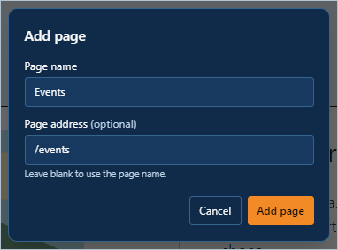
Give the page a name. Leave Page address blank to derive it from the name, or enter an address such as /events.
Control | What it does
Add page | Open the new page dialog from the toolbar or Page tools. In the dialog, Add page creates the page and Cancel closes without creating it.
Page name / Page address | Name appears in the editor tab. Address becomes the route. Keep addresses distinct and use simple lowercase names such as /weekly-bulletin.
Page tab | Switch the active page. Each page holds its own blocks.
Pencil / Duplicate / Search details | Rename the active page, create a copy, or edit page-specific metadata.
Link icon / Trash | Change the address of a non-Home page or confirm its deletion when allowed. Recheck navigation links after either action. Home keeps the root address /.
Page tools → Plan pages / Check site | Review suggested standard pages or inspect issues. Plan pages is separate from the optional AI tools.

Example. Choose Add page, enter Events and /events, and confirm. Add a Hero and text. Then open the Navbar properties and add an Events link pointing to the new page.

Page addresses and search details
Control | What it does
Page address dialog | Edit the route for a non-Home page. Use a unique address such as /community-events. Select Save address to apply it.
Update links option | Choose whether the editor should update supported references to the old route. Check custom code and any links that use a full web address afterward.
Page search details | Enter a page-specific title and description. A blank field uses the site default when applicable. Choose Save details to apply, or Cancel to leave the page unchanged.
Delete page confirmation | Review the warnings and listed referring pages. Cancel if the page is still needed. Remove or repair references after deletion and run Check site.
Duplicate page | Make a new page copy and edit its tab name and address. A duplicated article starts as a draft.

Rename a page without breaking links
Keep the route /events when you only want the editor tab to read “Community Events.” If you also change the route, review Navbar links, footer links and any images that linked to the original route. Test the old and new addresses before distributing links.

Plan pages and check the site
Control | What it does
Page tools → Plan pages | Show the available page plans. Tick the pages you want, then select Review plan to see proposed additions.
Review changes | Read the plan before applying it. Change selection returns to the checkboxes. Add pages applies the reviewed additions. Cancel closes the planner.
Page tools → Check site | Scan the project for issues. Read the issue message and location before making changes.
Open this block / Open this page | Navigate to the flagged object or page and close the report. Rerun Check site after correcting the issue.
Close | Dismiss the report. Export has a separate review of the actual generated files.
Search details | Use the magnifier on the active page tab. Review the title and description overrides alongside the defaults from Settings. Save the dialog values to apply changes.

Try it
Put a Navbar link on Home that points to /events. Open Preview and click it. Return to editing and run Check site after all destination pages have been created. Repeat for links to an anchor and for any media referenced by the page.

Preview and responsive layout
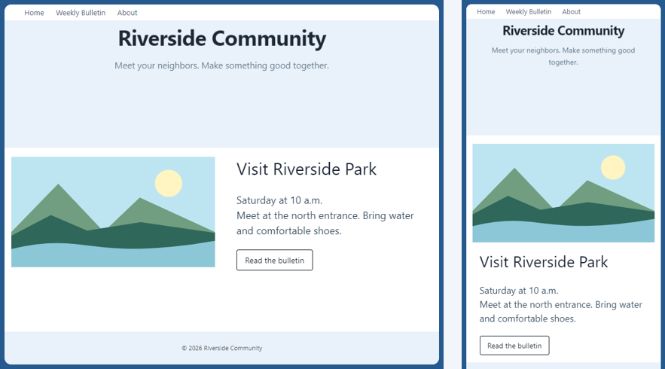
Tablet keeps the related items side by side. Mobile stacks them within the page.
Control | What it does
Desktop / Tablet / Mobile | Choose a viewing preset. Check all three before exporting, especially pages with text beside a portrait or several photos in one row.
Width slider | Simulate any width from 320 to 1920 px. Check widths between presets to catch abrupt wrapping.
Mode | Beginner is the regular editing view. Designer exposes additional controls. Professional (JSON) adds code-oriented work. Select a mode when the guide names a control you cannot see.
Preview / P | Hide editing affordances and follow supported page and anchor links. Press again to edit.
Hide on desktop / tablet / mobile | In a block's responsive settings, mark widths where the block should be hidden for visitors. An editing badge can still show the block at that width.
Stack section objects on phones | Use a flowing stack for section objects on narrow screens when the option is present. Check the resulting reading order.

Keep a heading, picture and caption in the same section or panel so they can reflow together. Use Desktop to set spacing. In Tablet verify the portrait stays beside its text where room allows, and in Mobile verify the image is centered and readable when stacked.

Undo history and keyboard controls
Control | What it does
Undo / Ctrl+Z | Undo the last project change outside text-editing controls. Use the text field's own undo during typing.
Redo / Ctrl+Y | Reapply an undone change. Making a new edit can replace the redo path.
Advanced → Undo history / H | Open the session history. Choose an entry to return to that state. Save separately for a checkpoint that survives a restart.
Keyboard shortcuts / ? | Open shortcut help. Escape closes a menu, cancels placement or clears the current selection as applicable.
Shift+click / Alt+click | Add objects to a multiple selection or cycle through overlapping objects. Use Layers to identify the intended object by name.
Arrow keys / Shift+arrow | Nudge a selected section object. Shift uses a larger increment. When text is being edited, arrows move the text cursor.
Ctrl+C / Ctrl+X / Ctrl+V | Use standard keyboard commands for selected text. Confirm the caret or outline is where you intend before pasting.
Delete / Ctrl+D | Remove or duplicate the focused section object. Delete in a text field edits text. Undo immediately if the wrong object is affected.
P / J / H | Toggle Preview, Project JSON or Undo history when focus is outside text entry. The shortcut dialog also lists numbered navigation shortcuts.

Components and layers
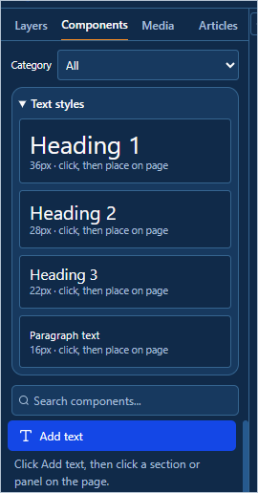
The Components palette offers text presets, categories, search and reusable sections.
Control | What it does
Layers / Components / Media / Articles | Switch between object hierarchy, addable elements, media and article details.
Category / Search components… | Narrow the component list by category or type. Choose All or clear the search to see more choices.
Heading 1 / Heading 2 / Heading 3 / Paragraph text | Start a text object at 36, 28, 22 or 16 px. Select the preset, then click the target section or panel.
Add text | Arm general text placement. Click the canvas to create the editable box. Press Escape to cancel placement.
Component tile | Click to add a page block, or drag a supported tile to place it. Panel uses click-to-place when selected from the palette.
Reusable sections | Select a block, enter Section name and save a copy. Click a saved name to insert a new copy on the current page. Remove deletes the saved reusable entry.

Example. Filter to Media to find Gallery, Photo collage, Document library, Image, Video or Strip. Choose All to return to Navbar, Hero, Content, Footer and other types.

Select move and resize
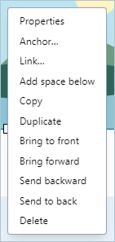
Right-clicking a selected image opens object actions and exposes its resize handles.
Control | What it does
Single click | Select an object. Clicking a panel body selects the panel. Click a blank area of a section to select its block or section.
Double click | Edit the text of a text object or an editable text area. With a panel, double-click its text to edit it without moving the panel.
Drag / four-way cursor | Move a selected object from its surface or available move edge. For text, leave editing before dragging the box.
White handles | Resize a selected object by an edge or corner. A photo preserves its aspect ratio where the image control supports it. The box tracks the resized item.
Right-click → Properties | Open focused properties for the item under the pointer. An object menu also offers actions such as Copy, Duplicate, ordering and Delete.
Click elsewhere / Escape | Dismiss the active menu or selection. Click the item again if you need its handles.

For blocks, right-click to use Move up, Move down, Duplicate or Delete. For a repeated card or gallery entry the menu also offers Move item up/down, Duplicate item and Remove item.
Example. Place a picture in Section 1. Click once, drag its corner inward, then drag the picture to Section 2. Confirm the destination section before releasing. Use Undo if you dropped on the wrong target.

Layer order and overlap
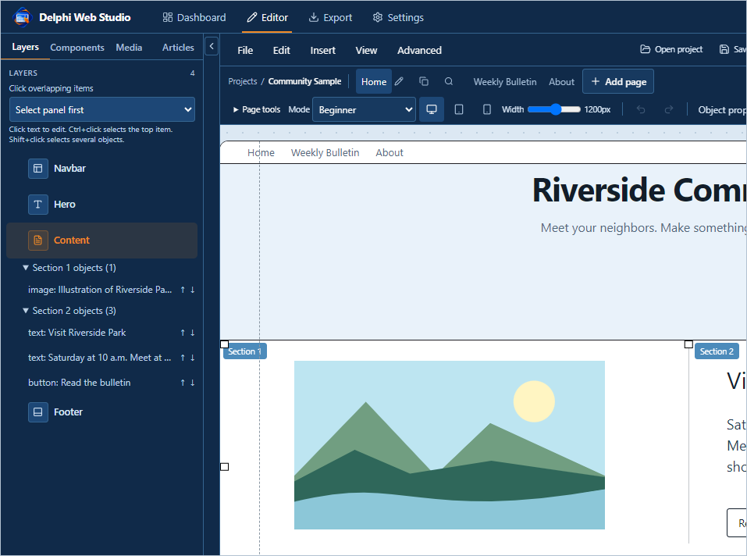
Use the Layers tree to select the object you need. Expand its parent block and section.
Control | What it does
Layers list | Expand the current block and its sections to select an object by its label or type. Use the list when a picture or text box covers the item you need.
Drag a Layers row | Reorder or move a section object to an eligible Layers destination. Check the selected item and the destination after the drop.
Shift+click | Select several section objects for supported group movement. Drag one of the selected objects to move the selection together.
Alt+click / Select layer | Cycle stacked objects at a point or choose one from the context menu when overlapping candidates are shown.
Bring to front / Bring forward | Put a selected object above all other local layers or one step closer to the front.
Send backward / Send to back | Move one step down or below the other local layers.
Copy / Paste / Duplicate / Delete | Copy an object for placement elsewhere, paste into a compatible section using its menu where available, duplicate in place, or remove it.
Selected object tools | Select two objects in the same section to enable Left, Center, Right, Top and Bottom. Select three or more for Distribute. Bring to front, Properties, Duplicate and Delete act on the current selection where enabled.
Layer order | Set stacking numerically. A higher layer appears in front of a lower one within its local stacking area.

Place an emblem over two photos
Add two images side by side, add a third smaller image, and drag it over their seam. Choose Bring to front for the emblem. If it covers an underlying handle, use Layers to select the underlying photo.

Reading the layers and object tools
Control | What it does
Overlapping item selection | Choose the default priority for selecting a parent or child when elements overlap. Alt+click still cycles candidates.
Block row drag handle | Drag to reorder page blocks. Duplicate and Remove act on the block row, including the items it contains.
Section or object row | Select the row to locate the item on the canvas. Open the block's section list when several rows have the same name.
Object row arrows | Move a section object's order forward or backward. Confirm the stacking on the canvas.
Properties / Bring to front | Open selected object fields or move the selection forward in the local stack.
Align Left / Center / Right / Top / Bottom | Select multiple objects in the same section first. The buttons align their corresponding edges or horizontal centers.
Distribute | Select at least three objects in the same section. Use it to space comparable elements evenly and then review the final arrangement.

Example. Select three image cards with Shift+click, align them at the top, and choose Distribute. Resize or move one individually if you want to break the alignment.

Floating settings windows
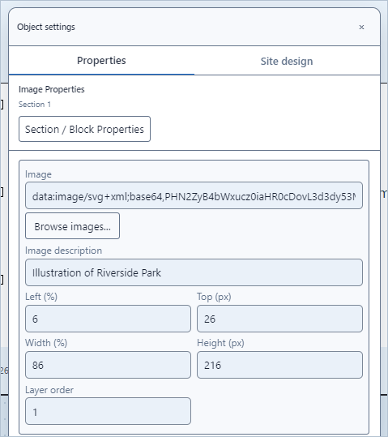
The floating Image Properties window shows the selected image and groups geometry fields side by side.
Control | What it does
Properties | Use the object's context menu to edit only that selection. The window is anchored near the object when there is room.
Window title / X | Drag the title area to move the window. Use X to close. Scroll within the window to reach fields below the visible area.
Section / Block Properties | Step up from the selected object to its containing block. Use the canvas or Layers to select the individual item again.
Properties / Site design | Switch between selection-specific fields and theme settings for the site.
Left (%) / Top (px) | Set horizontal position within the section and vertical offset in pixels.
Width (%) / Height (px) | Set size relative to the section width and in pixels vertically. Move or resize directly on the canvas if you prefer.
Layer order | Choose which nearby objects appear in front. Use the order commands for quick changes.
Image / Browse images… / Image description | Use an existing media entry or compatible source. Describe the visible subject in a short phrase for accessibility.

Right-click the object and use Link… or Anchor… for destinations. Their separate dialogs leave the ordinary geometry and appearance fields easier to scan.

Block and item property fields
Control | What it does
Block background / Background color | Set the fill behind that block's content. A light swatch can represent the theme default until a custom value is selected.
Content and Style sections | Expand a heading to show that group's fields. Variant changes the arrangement of the selected block.
Number of sections / Reset section widths | Choose one to four sections and reset divider proportions when needed.
Section N additional items | Edit earlier section content where present. Set text, image, image description, link or panel appearance on the relevant entry. The newer section object controls give each item its own geometry.
Choose image to adjust / Reset selected image | For composite blocks with several images, select the target image and use Image width, Image height, Move right or left, Move down or up, and Image layer order. Reset clears the selected image's adjustments.
Section text size and color | Set the section-wide text size and color where supported. Explicit rich text formatting can override these defaults.
Choose text to adjust / Font for selected text… / Reset selected text | Set size, color or font for a named field in the selected block, or clear its adjustment.
Screen visibility | Choose which device widths should omit this block in Preview and output.

Example. Open Hero properties, use Reset headline position if the title moved off the canvas, then increase the headline box width. Return to the canvas and edit the actual text with a double-click.

Build and resize sections
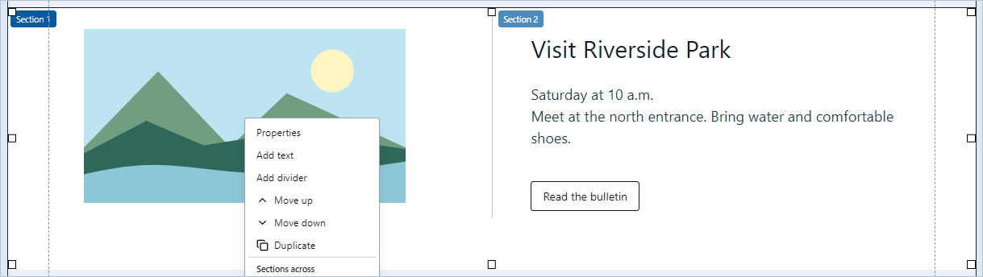
The two section labels and center divider identify where the image and text will be placed.
Control | What it does
Block context menu → Sections across | Set one, two, three or four sections. The first contains the original block. Other sections can hold independent objects. Lowering the number hides extra sections and preserves their contents.
Vertical separator | Drag between adjacent sections to change their proportions. Reset section widths returns them to equal widths.
Section badge | Identifies the target while editing. These labels and the light gray guides stay in the editor.
Add text / image / button / panel / collage | Create independent objects in the selected section. Placement commands let you choose the spot. Existing images and text can coexist in one section.
Snap section objects to alignment guides | Enable snapping to nearby edges or centers while dragging. Blue smart guides show when features align.
Stack section objects on phones | Let objects flow into a vertical order on a narrow screen when you want a simpler mobile arrangement.
Bottom and side handles | Adjust the height or width of the whole block. For a lower edge that stops shrinking, check the lowest object or remove excess section spacing first.
Block background / Reset background | Use the color picker to fill the whole block including resized space. Reset background clears the custom fill and restores the theme/variant choice.

Make a split feature
Add a Content block and clear its starter body. Set two sections and drag the divider to make the first wider. Place a landscape image in Section 1 and a heading, paragraph and button in Section 2. Verify the composition in all three preview widths.

Add and edit text
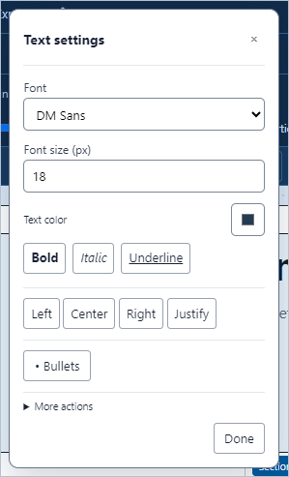
Text settings opens next to the edited box. The Windows app uses a native Font dialog, while the browser surface shown here uses a font list.
Control | What it does
Insert → Text / Add text | Click the target section or panel to add a movable text box. Select a text style to start at a specific size.
Double-click text | Place the insertion point. Select the characters you intend to format. Click again where you want to type or paste.
Font / Font size (px) / Text color | Choose a typeface, enter a size from 6 to 200, or pick a color. In the Windows build the Font button opens the Windows font dialog.
Bold / Italic / Underline | Toggle emphasis on the selection. Highlight the words again when applying another change.
Left / Center / Right / Justify | Apply alignment to the selected text range or paragraph runs. Use separate paragraphs if you want a heading centered and the following body left-aligned.
Bullets | In a multiline box, select lines and choose Bullets to format them as a list.
More actions / Done / X | Expand editing commands or close Text settings. Click the outline or use Layers to select the whole text box.

Example. Add Heading 2 above a meeting paragraph. Center only the heading. Select three separate lines in the paragraph and apply Bullets. Select the box border and resize until the list wraps comfortably.

Text boxes and content blocks
Control | What it does
Text box outline / handles | Select the whole object and drag an edge to give a long title more room. Keep some room on both sides of a heading.
Clear text / Delete object | Select characters to erase them while keeping the box available for typing. Use Delete from the object menu or focused object outline when you intend to remove the entire box.
Cut / Copy / Paste / Select all | In Text settings, operate on text in the active box. For a reusable object with formatting, copy or duplicate the object itself where supported.
Content block → Body | Edit the block's built-in long-form copy. The body supports headings, bold, italic, lists and links through Markdown.
Bold / Italic / Heading / List | Select text in Body and apply the corresponding markup. For a multiline placed text box, use the Bullets control described in the text chapter.
Insert page link / Insert media link… | Select the words to use as the label. Choose a page or a project file to insert its link into Body.
Content Variant | Prose, Columns and Highlight change presentation of the built-in body. Independent section objects give precise placement beside or over other items.

Preserve a formatted paragraph
If you need a styled paragraph in another section, move the whole text object. For a new copy, duplicate the object and move the duplicate. Compare the font, color and line breaks in Preview before deleting the original.

Panels buttons and attached objects
Control | What it does
Insert → Panel / Components → Panel | Choose Panel and click a section. Drag or resize the selected panel independently of the block behind it.
Panel background color / Text color / Font size | Adjust the fill and the panel's own text. Use a color with sufficient contrast.
Add text to panel / place on panel | Place a text object over the panel so the panel can own it. An attached object follows when the panel moves. An unrelated object can overlap without being attached.
Select panel / Select text | Click the panel surface to work on its geometry, or double-click its text. Use Layers or Alt+click when a child covers the surface.
Add button | Create a section button. Use its label for the visible wording and Link… for the page, anchor or web destination.
Position / Layer order | Set precise placement for the panel or button. Use front/back commands if an overlapping item is hidden.

Build a portrait card
Place a panel in the right-hand section, set a light background, then add a portrait and a short name on the panel. Move the panel and confirm its attached contents move with it. Add a Read more button below it and link it to /about.

Space strips and decorative lines
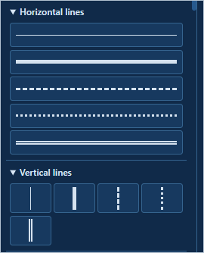
Horizontal and vertical presets show the stroke before you place the line.
Control | What it does
Components → Media → Strip | Adds a strip, usually after the current selection. Use Space for blank space, Line or Dots for a visible separator.
Strip Width / Height (px) | Choose full, centered or narrow, then set its height or drag the top/bottom handles. A strip can hold independent section objects.
Insert → Line | Arm a line object for placement. Click inside the section where it belongs.
Horizontal lines / Vertical lines | Open the decorative presets. Choose Thin solid, Thick solid, Dashed, Dotted or Double, then click the canvas.
Line direction / Line style / Line thickness / Line color | Change orientation, stroke pattern, weight and color in the line object's Properties. Resize the length with its handles.
Add space below / Enter on a selected image | Use the object context menu or the keyboard. Add 32 px of extra section space per press. Select the image object first. In a text box Enter creates a new text line instead.

Example. Select the block above Footer, add a Space strip, and adjust its height to leave about two lines of space. Place a thin gray horizontal line in it. Preview on Mobile to confirm the separator fits.

Link to a page or an anchor
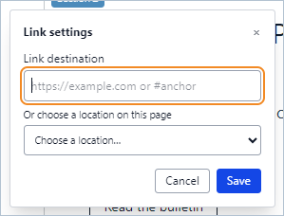
Link settings accepts a URL or a named jump location on the current page.
Control | What it does
Anchor… | On a supported object, use its context menu. For a whole block use Anchor (jump destination) in block Properties where shown.
Anchor name | Start with a letter. Use letters, numbers, hyphens or underscores. Keep the name unique on its page, for example parish-mass-times.
Link… | Open a supported image or object's link dialog. Enter a safe web address, select an internal page, or select a jump location.
Choose a location on this page | Insert the #anchor destination for a named target on the current page.
Choose a site page | Insert the page route. For a page-plus-anchor link, use the route and hash when supported by the link field and verify it in the exported site.
Save / Cancel / Close | Commit the destination, leave it unchanged, or dismiss the settings window. Clear an existing value to remove its link or name.

Link a photo to Mass times
On the schedule block set parish-mass-times as the anchor. Right-click the photo, choose Link…, and select that anchor or enter #parish-mass-times. Enter Preview and click the image. The page should scroll to the schedule.

Find and import media
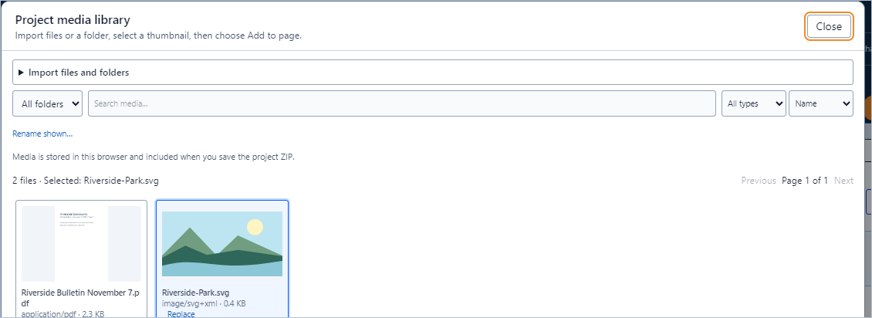
The media picker shows thumbnails, filters, and a primary action for the selected file.
Control | What it does
Import media / Import folder | Choose individual files or a directory. Use a folder for a group such as Event Photos. Supported media can also be dropped into an import area.
Allow ZIP archives | Permit importing compatible files from an archive. Leave off when selecting individual files.
When files match | Reuse existing shares the stored asset, Keep separate copies creates distinct entries, and Skip duplicates omits matching files.
All folders / Unfiled / Search media… | Restrict to the imported folder, items without a folder, or names matching the search.
All types / Name | Filter Images, PDFs, Audio, Video or Other documents. Sort by Name, Date, Size or Type.
Thumbnail / Previous / Next | Select a file and read its name, size and available dimensions. Browse more result pages with Previous or Next.
Add to page / Choose file / Close | Place or add media to the page, fill the property that opened the picker, or dismiss the window.

Manage a large media collection
Control | What it does
Rename shown… | Give the currently filtered result set a numbered prefix. Review the confirmation and its sample name before applying.
Undo renames | Restore available prior names for the project's renamed assets.
Replace / Undo replacement | Substitute a new file for an existing asset where offered. Check every page using the asset. Undo replacement restores the available prior asset.
Cancel / Resume import / Discard list | Stop a running import, resume the remaining list in the original project, or discard the remaining list. Already imported files can remain in Media.
Import failures | Expand the failures summary to see which files were skipped and why. Correct or convert files before retrying.
Preview PDF | Open a stored PDF for review from its card. Close the viewer to return to the collection.
Media card drag | Drag from the left Media view to a target. Images can be placed within a section. Other media use their supported block or link behavior.

Example. Import a folder containing 100 event pictures. Filter to Images, choose the folder and search for “picnic.” Select the thumbnail and choose Add to page. Use Browse images from Gallery properties when the selected file belongs in a gallery instead.
Save to a project ZIP to retain the media with the editable project. Keep a separately exported Website ZIP for hosting.

Image blocks and image objects
Control | What it does
Image object / Image block | A placed image is an independently movable item inside a section. The Image palette tile is a full block with variants and optional adjacent content.
Image URL / Browse images… | Use a safe image URL or pick a local file through the library. For a portable project, prefer imported media.
Alt Text / Image description | Describe the subject or purpose, such as “Entrance to Riverside Park from Oak Street.”
Image link | Set a page, anchor or web URL. On a placed image use its Link… action.
Title / Subtitle / Image Side | Add supporting copy and select the side for the side-by-side block variant where appropriate. Leave optional text blank for an image alone.
Hero image / Side by side / Grid | Choose a wide photo, a photo paired with copy, or a list of images. In a grid, use the Images list to add and order entries.
Image fit | Cover fills and can crop, Contain shows the full photo with possible spare space, and Fill can stretch.
Section width / Image height / Left position / Vertical spacing / Layer order | Set the block's size, offset, optional overlap and stacking. Use the handles for visual adjustments.

Example. Import an illustration and choose Add to page. Place it beside a paragraph in the same block, drag a corner to scale it, add a description, then inspect Desktop, Tablet and Mobile.

Galleries and layered collages
Control | What it does
Gallery → Title / Images / Variant | Set a heading and choose Grid or Masonry. Add media through the Images list, supply descriptions and reorder the rows.
Photo collage | Use a whole-block collage or an independent collage in a section. For an existing compatible block, use Move collage into a section… and click a destination.
Collage photos / Browse collage images… | Add images from the library. Set a readable description for each and remove unwanted entries in the collage's own properties.
Image handles | Select a photo inside the collage to move and resize it. Select the collage container to move or resize the entire arrangement.
Left / Top / Width / Height | For photos in the collage editor, percentages describe their positions and sizes within the collage. Change one photo at a time to keep its neighbors in place.
Layer order / Bring to front / Send to back | Set how photos overlap. A larger layer number is in front.
Remove / Duplicate | Use the item list or context menu to change a specific entry. Verify whether you selected an individual photo or the container first.

Four photos with a center emblem
Add four photos and move them into a two-by-two arrangement. Add a smaller emblem over the joins and bring it to the front. Drag the collage by its outer outline to move all five together. Check the preview at a phone width.

Video audio and documents
Control | What it does
Video component → Video URL / Title / Platform | Paste a supported YouTube or Vimeo URL, choose the matching platform and give the embed a title. Internet access and the provider's embed policy apply.
Uploaded video / audio | Import a supported local file and add it from Media. Give the resulting block a title. Visitor playback depends on browser support for the file's format.
Visitor media controls | Play or pause, seek, adjust volume or open fullscreen where the browser exposes it. Test the exported files in your target browser.
Document | Add a stored file as a document block or choose it as a content link. Title is the visible document label.
Document library → Title / Documents | Give the collection a heading. Add entries, choose files, and edit each title and description. In the regular library visitors can search titles and descriptions.
PDF viewer | Use a PDF block for an embedded document. For a current bulletin and recent archive use the Weekly Bulletin page.

Example. Add Meeting minutes to a document library, choose a PDF, and add a description “October planning meeting.” In Preview enter October in Search documents and verify the correct item remains.

Create and update a weekly bulletin
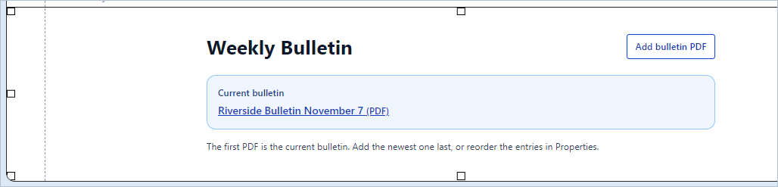
The editor marks the first bulletin Current bulletin. The Add bulletin PDF control is for the editor.
1. Open the existing Weekly Bulletin page. To set up a new one, follow “Project JSON and custom code” to configure its Document library block. Use /weekly-bulletin as the address.
2. Click Add bulletin PDF. Open Import files and folders if needed, choose a PDF or its folder, select the thumbnail and click Choose file.
3. To add several existing editions, add the oldest first and the newest last. Each newly chosen bulletin moves to the first position. The page shows the first five valid stored PDFs, including the current edition.
4. Use the Document library properties to correct titles, descriptions or ordering. Move the edition you want featured to the first position.
5. Add or update the Navbar link with the Weekly Bulletin page route. Use Preview to open the current PDF, then Save to keep the editable ZIP.
Example. Select October 25, then November 1, then November 8. The November 8 issue appears first. If you select an older existing file again, check the ordering before saving.

Read a PDF in the viewer
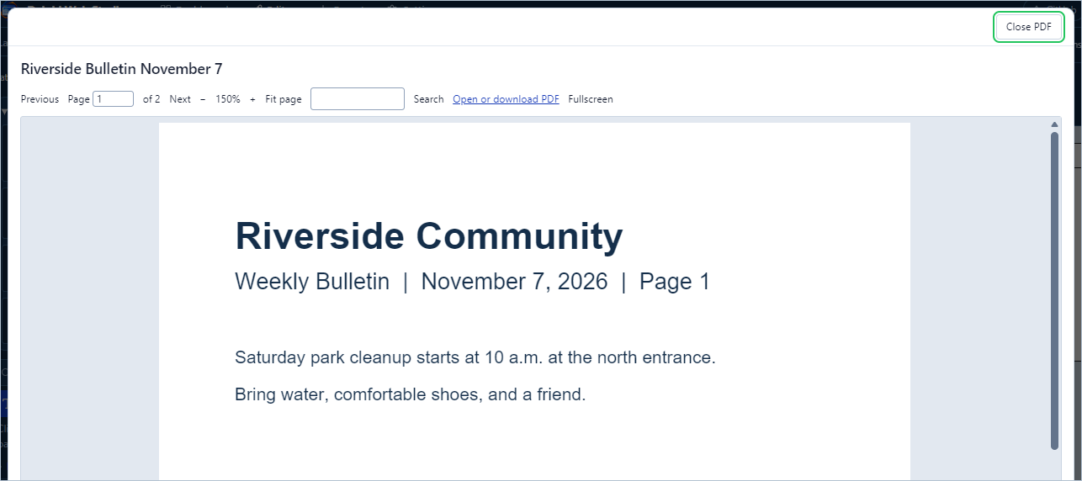
The bulletin viewer opens the document with a toolbar and a scrollable page area.
Control | What it does
Close PDF | Return to the bulletin list. In Preview a local bulletin opens in this viewer. The exported bulletin page links to the PDF for the visitor's browser to open.
Previous / Page / Next | Go back one page, type a valid page number, or go forward one page. “of” shows the page count.
Minus / zoom readout / Plus / Fit page | Zoom out or in with the buttons. The readout shows the current scale. The bulletin starts at 150%. Use Fit page when you need the whole page at once.
Scroll bars / Fullscreen | Move horizontally and vertically when the zoomed page extends past the reading area. Use Fullscreen for more space.
Search PDF text / Search | Type a word or phrase and press Enter or Search. Use page thumbnails or Open PDF to print when those options are enabled. An image-only scan needs a text layer to be searchable.
Open or download PDF | Use the original document outside the viewer. Browser settings determine whether the file opens or downloads.
PDF block settings | Set Title, Caption, Accessibility label, Height, Starting page, Fit mode and Mobile display. Show thumbnails, search, print, download and fullscreen control which tools are offered.

Navbar controls and page links
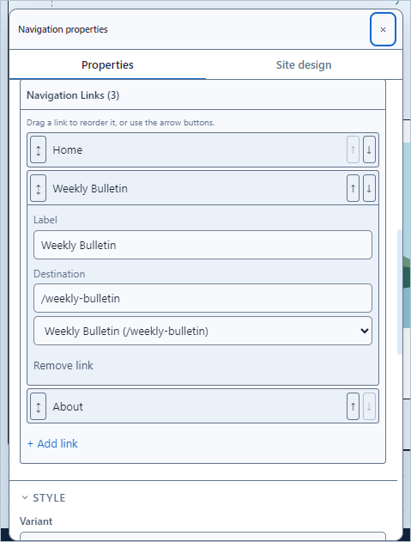
The compact Navigation Links list keeps each destination in its own expandable row.
Control | What it does
Components → Navbar | Adds a navigation block at the top of the page. Its links are controlled by the editor. Set up or reuse it on each page where visitors need navigation.
Share across pages / Stop sharing across pages | Right-click the Navbar or Footer. Share it to link copies across pages, or stop sharing to edit each copy independently.
Properties → Navigation Links | Open the compact list. Click a link name to expand just that link's fields.
Add link | Append a new entry. Enter a Label and Destination or use Choose a site page. Home uses /.
Drag handle / Up / Down / Remove link | Reorder entries by dragging or using arrows, or delete one entry. Dragging the links on the Navbar is also available in editing.
Logo Text / Logo Image URL | Leave both blank for a text-only navigation bar. Set these only if you want a brand label or image.
CTA Button / CTA Destination | Set an optional highlighted link and its destination. Leave the button label blank to omit it.
Variant / Navbar width / Navbar height / Background | Use Default or Centered, set size and choose a contrasting fill. Resize on the canvas with the block handles. Use Site design text colors for theme-driven link text.

Example. Add Home, Weekly Bulletin and About in that order. Select each destination from the site page list. Set a white block background, then check link contrast and hover behavior in Preview.

Footer and linked resources
Control | What it does
Footer → Variant | Choose Simple, Multi-column, Minimal or Resources. Use Resources for a group of linked graphics and separate text buttons.
Logo Text / Logo Image URL / Description | Set optional brand details. Clear the logo fields for a footer without branding. The footer omits the former default placeholder brand and green dot.
Copyright | Enter your credit, for example “© 2026 Riverside Community.” Add an independent text object for longer attribution, a photo credit or contact details.
Navigation destinations / Legacy text-only labels | Choose real links for visitor navigation. Review older text-only entries if you open an existing footer.
Resource images and links | Add one item per image. Select its media, then set visible label or description and the destination address.
Resource buttons | Add a short label and an internal, external or anchor destination. Use reorder controls to put the most important resources first.
Share across pages | Use the footer context menu to keep the footer in sync across pages. Stop sharing if one page needs its own version.
Footer text boxes | Click to select the box and double-click to edit its words. Select empty footer space to edit the block itself. Use Layers when items overlap.

Example. Choose Resources, add images for Donate, Volunteer and Visit, then add buttons for Directions and Contact. Preview the footer at phone width and follow each link.

Hero content and announcement blocks
Control | What it does
Hero → Badge / Headline / Subheadline | Enter the small optional label, main heading and supporting sentence. Resize or reposition the headline and subheadline boxes. Use their reset controls if they move out of sight.
Primary CTA / Primary CTA URL / Secondary CTA / Secondary CTA URL | Set optional action labels and destinations. Leave labels empty when you do not want buttons.
Hero Image URL / Variant | Choose an image and Centered, Split, Gradient or Minimal presentation. Check contrast across the full image when placing text over it.
Hero width / Hero height | Set exact dimensions or use canvas handles. A section can require more height when it contains tall objects or long wrapped text.
Banner → Text / Link Text / Link URL | Write a short announcement. Fill in link text and destination if visitors should be able to open more information.
Banner Variant | Choose Ribbon or Bar. Check the banner at phone width to see whether its message wraps.
Call to Action → Headline / Subheadline / Button Text / Button URL | Make an invitation and supply its destination. Choose Simple or Split in Variant.

Example. Use “Riverside Community” as the Hero headline. Put the park cleanup date in a Banner and link “See events” to /events. Clear both Hero action labels to keep the introductory area simple.

Cards lists and social proof
Control | What it does
Features → Section Label / Title / Subtitle / Feature Cards | Introduce the list and add cards with a title and description. Try Grid, List or Alternating.
FAQ → Title / Subtitle / Questions | Add a question and answer per entry. In Preview open and close the accordion entries.
Team → Title / Subtitle / Members | Add names, roles and available portrait fields for the team grid. Use the media picker for images.
Testimonials → Title / Subtitle / Testimonials | Add a quote and its attribution details. Switch between Cards, Carousel and Spotlight.
Stats → Title / Stats | Enter each value and label. Compare Grid, Bar and Counter in Preview.
Logo Cloud → Title / Logos | Add logo source entries for partners or sponsors. Keep contrast and image clarity consistent.
Item rows / Add item / Remove / drag / arrows | Add, remove, duplicate or reorder repeated entries where supported. A row's fields depend on the component.

Example. Add FAQ and enter “Where should I park?” with directions. Add a second question, use its arrow to change the order, then test both from Preview. Add no placeholder rows to a finished page.

Contact forms and newsletter controls
Control | What it does
Contact → Title / Subtitle | Explain why visitors should use the form and what to expect after submitting.
Webmaster contact email | Set the default recipient in Settings → Project settings. Save the project after changing it.
Contact Email | Set a recipient for this block if it should override the project default.
Form service HTTPS URL | Enter the URL of a compatible external form service when you want direct submissions. Test that service with a non-sensitive message.
Privacy and consent notice | Enter the optional notice. When supplied, the visitor must tick the accompanying box before sending.
Name / Email / Message / Send Message | Fill in the required visitor fields and submit. Editor Preview shows the behavior without sending. An exported form without a service uses the visitor's email app if configured.
Newsletter → Title / Subtitle / Button Text / Social Proof | Set the presentation and test the exported behavior. A newsletter block alone does not set up a mailing list or subscription service.

Example. Set webmaster@example.org as a sample address, insert Contact and leave Contact Email blank to use the default. Replace the example address with the real contact address before exporting.

Set the site design
Control | What it does
Site design → Presets | Apply a coordinated set of theme colors, fonts and corner radii. Change individual values afterward if needed.
Backgrounds → Base / Surface 1 through 5 | Base is the page background, including exposed side gutters in Editor and Preview. Surface values are used by component fills.
Text → Primary / Secondary / Muted / Dimmed | Set the theme's text hierarchy. Existing text with explicit formatting keeps its assigned color.
Accent / Accent Dim | Set accent treatments used by elements that follow the theme. Review links and button contrast in Preview.
Borders → Default / Subtle / Hover | Choose the theme colors used by borders and interactive hover treatments.
Fonts → Body / Display / Mono | Choose fonts for regular copy, headings and monospace uses. A separately formatted text box can use its own font.
Radius → Default / Large | Set the usual and larger rounding amounts in pixels.
Block background / Panel background color | Override one block or one panel without changing the site's Base. Use the color swatch or enter a valid hex value where the field is offered.

Example. To remove dark margins from a light page, set Base to #FFFFFF. Leave the Hero's custom green background in place. Set Primary text to a dark color and verify that separate explicitly formatted labels are legible.

Site settings and search
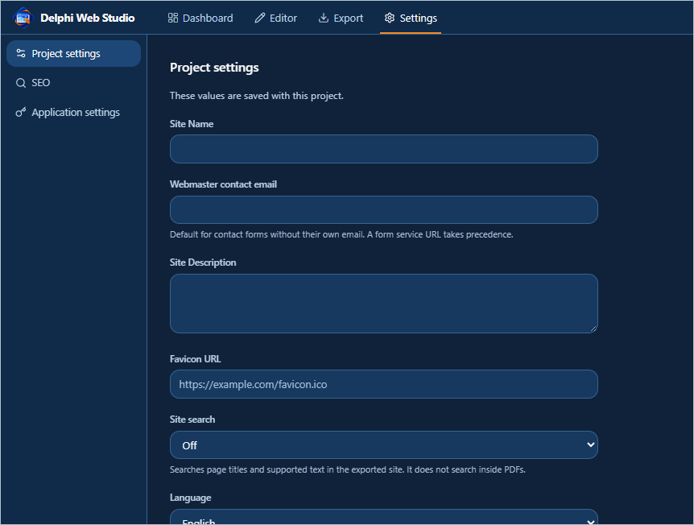
Settings separates project metadata, SEO and Windows account credentials.
Control | What it does
Site Name / Site Description | Set general site metadata. The project card name and individual page names can be edited separately.
Webmaster contact email / Favicon URL | Set a default contact address and a valid icon URL used by the site.
Site search | Choose Off or Include in website ZIP. If enabled, link to the search page from the Navbar or another element and test the exported search.
Language | Set the site's language metadata. Choose English, German, Spanish or French as appropriate for the content.
SEO → Page Title / Meta Description | Set site-wide defaults. Use a page tab's Search details to customize a particular page.
Public site URL / OG Image URL | Enter the actual HTTPS base URL when known and an image URL for link previews. The base URL also supports sitemap and related metadata generation.
Draft updated | Settings changes update the draft. Return to Editor and save the portable project to keep them in the file.

Articles author credits and tags
Control | What it does
Articles tab | Select a non-Home page, then choose Make this page an article to keep its current content and add article metadata.
Export status | Draft omits the article from the website ZIP. Ready includes it. Change the status only after checking the page and any links to it.
Author / Summary | Add a byline and short description. Review how these appear on the article and its index.
Tags / Add tag / Remove | Type a topic and add it with the button or Enter. Remove individual tags with their adjacent control.
Article links and index | Link to a ready article or the generated articles index when available. Review the ZIP to verify both paths.
Footer credits / Text box | Use the Footer Copyright field for site-wide credit where present. Add an ordinary text box for photo attribution, author notes or other visible credits.

Example. Create Park Cleanup Recap, make it an article, add an author and the tag Volunteers, then mark it Ready. In Export, confirm the article is present in the file list.

Import HTML and WordPress content
Control | What it does
Advanced → Import HTML folder… | Choose the folder containing a static site's HTML pages and assets. Inspect detected pages, skipped files and reference issues in the import report.
Review reference issues | Check links and assets that need attention. Where the report provides source paths, use them to identify missing files.
Advanced → Import WordPress content… | Select the WordPress XML export file. Read the page, article and conversion summary before importing.
Create imported project / Cancel | Create a separate local draft from the reviewed import or dismiss the review. Keep the original source files until you have compared the result.
Inspect imported source | Use Professional mode and the code drawer to inspect available original source snapshots.

Example. Import a small local HTML folder, open Home and About, compare heading order and images with the original, then save the draft to a new project ZIP.
Imports convert supported content to editable blocks. Plan to rebuild unsupported themes, scripts and plugin behavior. For WordPress hosting, this app's current export is a static website ZIP and does not install an editable WordPress theme. Wix project import is outside the current editor.

Project JSON and custom code
Control | What it does
Mode → Professional (JSON) / Advanced → Project JSON | Open the active configuration. Save a separate copy before making hand edits.
Edit / Apply / Cancel | Make a draft, validate and apply it, or discard it. Read validation messages. If the project changes while editing, copy your draft, cancel and reopen.
Inspect page HTML / Inspect imported source / Back to JSON | Inspect generated markup or stored imported files, then return to the editable configuration view.
Custom HTML/CSS/JS | Edit custom code for the active page using the supplied fields. Review script behavior and use trusted code only.
Apply custom code / Preview HTML/CSS / Cancel draft | Save custom code to the page, view the available preview, or discard changes. Verify the exported site separately for script-dependent behavior.
Close | Dismiss the drawer and return to editing.

Enable a new Weekly Bulletin block
If your page already shows Add bulletin PDF, use it directly. To configure a new page in the current build, add a Document library block, give it the title Weekly Bulletin and save a copy. In Project JSON locate that page's block with type “documentLibrary” and change only its variant from “default” to “weekly-bulletins”. Select Apply. Reopen the page and confirm Add bulletin PDF appears. Keep the original block ID and properties.

Optional AI and saved keys
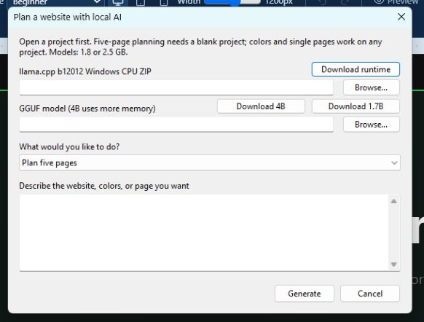
The desktop Local AI window accepts a runtime, model and request.
Control | What it does
Settings → Application settings → Gemini API Key | Enter a Google Gemini key if you use an AI feature that needs it. Treat the value like a password and use your own account.
Save key / Remove saved key | Store the key in Windows Credential Manager for the current Windows account or remove it. It can be reused across projects on that account. A revoked or restricted key may need replacing.
Remove older saved key | Remove an older locally saved credential if this control appears. Keep a working key in the secure store if needed.
Deploy Access Key | Enter the key for a configured hosting service, when offered. It serves a different purpose from the Gemini key.
Desktop Local AI… → runtime / model / Browse… | Select the llama.cpp Windows CPU ZIP and a GGUF model. Download runtime, Download 1.7B and Download 4B are shortcuts for obtaining those files. The larger model uses more memory.
Describe the website / What would you like to do? | Type the request and select a supported operation. A five-page plan needs a blank project. Color and single-page proposals can be made against an existing project.
Generate / Cancel / proposal review | Generate a proposal, cancel, or review the result. Apply only the intended proposal. Save the resulting project explicitly.

Get a Google Gemini key
In Google AI Studio, open API Keys and choose Create API key. Select the Google Cloud project, copy the key, then paste it in Application settings and choose Save key. Delphi Web Studio Pro does not expire the saved entry. Google can revoke or restrict the key. Replace it if Google marks it blocked or your organization rotates it.
Google guide to Gemini API keys
Example. Ask Local AI for a single Volunteer page with a short introductory section, review the changes, apply the proposal, then add it to the Navbar.

Export and review website files
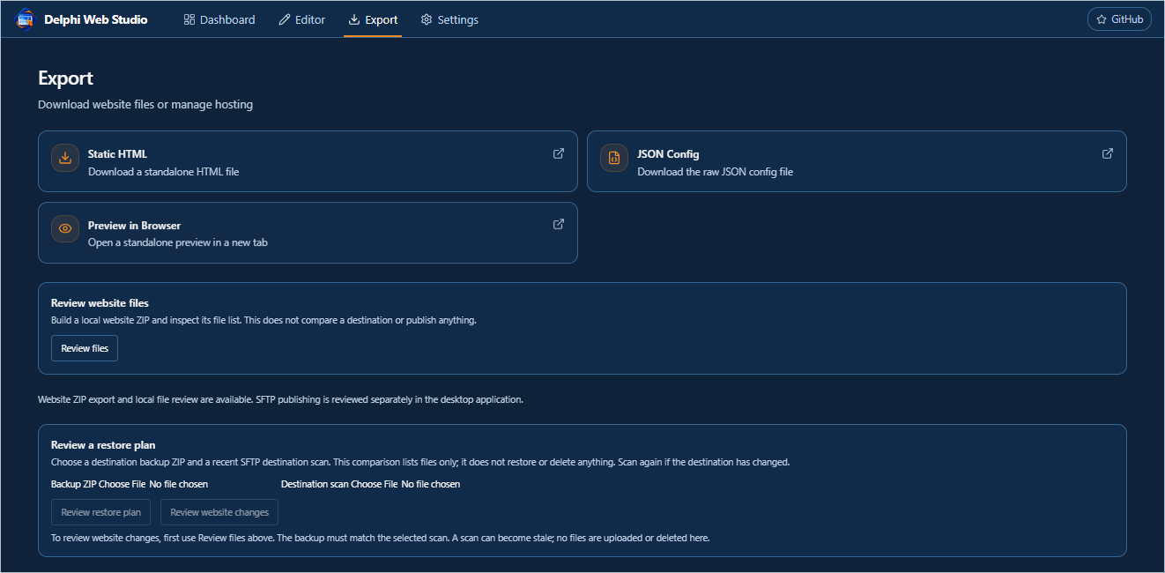
The Export screen separates file downloads, website review, and hosting actions.
Control | What it does
Static HTML / JSON Config / Preview in Browser | Save a standalone HTML view, download raw configuration, or open a standalone preview. Use the complete site ZIP for a site with multiple pages or media.
Website ZIP / orange Export | Generate website output with supported page files and assets. Keep the folder structure intact when unpacking or uploading.
Review files | Build and list the generated output. Read validation results and confirm the expected pages and media are included.
Download reviewed ZIP / Prepare file manifest / Download file manifest | Save the reviewed website or produce a separate inventory used to compare versions.
Compare manifest or destination scan | Select a previous inventory and inspect Added, Changed and Removed paths.
Review a restore plan / Review website changes | Choose the requested backup and destination scan files. Read the comparison before selecting any separate deployment command.

Example. Review Home and Weekly Bulletin in the generated file list. Save the Website ZIP, unpack it in a separate test folder, and check navigation, PDFs and image assets.

Hosting and deployment controls
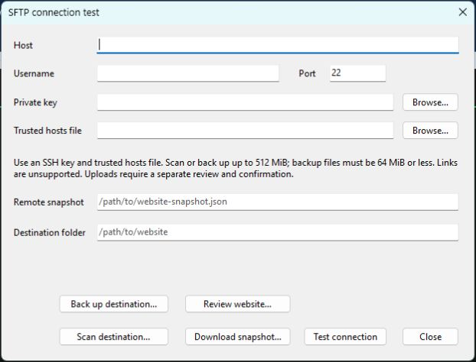
The SFTP connection window separates connection testing and read-only review from upload.
Control | What it does
Static hosting | Use hosting that serves the generated HTML, CSS, scripts and assets and supports the exported paths. Test the site from its actual host path before directing visitors to it.
GitHub button | Opens the Delphi Web Studio Pro software repository. Create and configure any website repository and Pages hosting separately. Saving or exporting a project does not push or publish it.
Publish to Web / Copy URL / Visit site | When a compatible publishing service is configured, review its separate publishing controls. Copy URL copies the assigned address. Visit site opens it.
SFTP connection… → Host / Username / Port / Destination folder | Enter the connection and target details supplied by your host. Use Test connection before deployment.
Private key / Trusted hosts file / Browse… | Select the SSH identity and the trusted host record. Keep secrets and recovery files out of public website directories.
Download snapshot… / Scan destination… / Back up destination… | Read the remote state, create its inventory, or back it up. Choose storage you control.
Review website… / Review files / Check destination | Select the Website ZIP, destination scan, backup ZIP and private recovery folder as requested. Inspect changes and destination checks before authorizing an upload.
Publish… / Review added rollback / Retain added files… / Close | Use the separate review and confirmation flows where available. A rollback review uses the original receipt. Close exits the dialog.

Example. Export and review a website ZIP locally. To keep the site private, stop after downloading or reviewing files and leave publishing actions unused.

Troubleshooting and final checks
Control | What it does
Black page margins | Open Site design → Backgrounds → Base. Compare with the block background. Check the same page in Preview.
Cannot select an item | Exit Preview, press Escape, then click once or find the item under Layers. Use Alt+click for overlapping objects and double-click to edit text.
Cannot shrink a block | Look for low or hidden objects and extra space. Move the lowest item up, then use the bottom handle and inspect the background.
Text formatting did not apply | Highlight the intended text before changing its font, color, size or alignment. Click Done and check Preview.
Media missing | Check the project ZIP or media filters. Select the asset again if the property refers to a path that no longer exists.
Link goes to the wrong place | Check the page address, anchor spelling and unique anchor name. Run Check site and test the link in Preview and in exported output.
Project still marked unsaved | Wait for an active save to finish. Verify the filename and timestamp. If it failed, use Save as to a known writable location and reopen the new file to confirm.
Diagnostics… | Open the desktop diagnostics screen for details when the editor cannot start or a native operation fails. Review the information before sharing it.

Before handing over a website
Confirm the editable project opens with its media. Check Desktop, Tablet and Mobile. Follow the Navbar, image links and anchors. Open a bulletin, verify search if enabled, and review the generated website file list.

